**Project report on**

**“Online bus ticket reservation system”**



**Co-supervised by**

**NasrinAkter**

Lecturer of

Department of CSE

Faculty of CSE

**Supervised by**

**Laila Arjuman**

Lecturer of

Department of CSE

Faculty of CSE

**Submitted By:**

**Group No: 03**

Md. Shadequl Islam (ID - 1420118)

Md. SohelRana (ID - 1420119)

KashmeryAktar (ID - 1420109)

Level-4, Semester- II

**Govt. Shahid Akbar Ali Science & Technology College (SASTC)**

**Baliadangi, Thakurgaon.**

**Affiliated by Hajee Mohammad Danesh Science & Technology University,Dinajpur.**

**Acknowledgement**

Firstly, unlimited praise to Allah as the number of his creatures, the gratification of himself, the weight of his throne, and the extension of his words. We would like to express deepest gratitude to my supervisor, **Laila Arjuman** and co-supervisor **NasrinAktar** for their excellent guidance, caring, patience, providing us with an excellent atmosphere for developing the system and providing confidence to us. Their comments and questions were very beneficial to completion of the online bus ticket reservation system, they gave me a lot of positive perspective in life. We thank them for challenging us to do this system development.

**Justify**



This is to certify that the dissertation titled, online bus ticket reservation system is a group work done by MD. SHADEQUL ISLAM, MD.SOHEL RANA & KASHMERY AKTAR during the academic session (2014-2017) is a partial fulfillment of CSE (Level 4, Semester-II) has been carried out under my direct supervision and guidance.

This report or a similar report on the topic has not been submitted for any other examination and does not from a part of any other course undergone by the candidate.

**------------------------------------ -----------------------------------------**

**Signature of supervisor Signature of co-supervisor**

**Laila ArjumanNasrinAktar**

**Abstract**

Traveling is a large growing business across all countries. Bus reservation system deals with maintenance records of each passenger. It also includes maintenance of information like schedule and details of each bus. The working of the bus reservation system that there are many operations, which are to do manually. It takes a lot of time and causing many errors while data entry. Due to this, sometimes a lot of problems occur and facing many disputes with customers. To solve the above problem, and further maintaining records of passenger details, seat availability, price per seat, bill generation and other things, this is the proposal of computerized reservation system. By using the proposed system, people can reserve tickets from any part of the world via internet. Customer can check availability of bus and reserve selective seats. The project provides and checks all sorts of constraints so that user does give only useful data and thus validation is done in an effective way. The proposed bus reservation system was developed using Hypertext Markup Language (HTML), PHP Hypertext Preprocessor (PHP), Structure Query Language (SQL), Ajax, Cascading Style Sheet (CSS), and JavaScript.

**Keywords:**Online bus ticketing system, Electronic payment system web development, Online reservation system, Routes plan, Price and Seat plan.

**TABLE OF CONTENTS**

**Chapter 1**

**Introduction Page**

1.1 Introduction……………………………………………………. 1

1.2 Background of the study……….……………………….…… 1-2

1.3General objectives……………………………………………. 2

1.4 Specific objectives……………………………………………. 2-3

1.5 Organization of the paper……………………………………… 3

**Chapter 2**

**Literature Review & Related works**

2.1 Introduction …………………………………………………….….. 42.2 The current system………………………………………………… 42.3 Drawbacks of current system…………………………………….. 4-5

2.4 Proposed system……………………………………………… 5

2.5Advantages of proposed system………………………………….. 5

2.6 Related works…………………………………………………...... 5-6

2.7 Research questions…………………………………………………. 6

**Chapter 3**

**Methodology**

3.1 Introduction …………………………………………………………… … 7

3.2 Functional requirements…………………….…………………………… 7 3.2.1 System Requirements………………………………………………….. 7

1. XAMPP server …………………………………………………… 7

2 Windows Server ………………………………………….. 7-8

3 Apache…………………………………………………………….. 8

4 MySQL……………………………………………………………. 8

5 PHP ……………………………………………………………….. 8

6 PhpMyAdmin ……………………………………………………. 8-9

7 HTML and CSS …………………………………………………. 9

8 Bootstrap …………………………………………………………… 9

3.2.9 JavaScript Framework (query) ……………………………………. 9-10 3.2.2 Hardware Requirements……………………………………………….. 10

**Chapter 4**

**Proposed system design**

4.1 Introduction……………………………………………………………….. 11

4.2 System user ………………………………………………… ………. 11

4.2.1 Activity of admin……………………………………………...... 11

4.2.2 Activity of user…………………………………………………. 11-12

4.3 Modules………………………………………………………………… 12

4.4 Use case diagram ……………………………………………. 12-13

4.4.1 Use case diagram of admin………………………………………. 13

4.4.2 Use case diagram of user…………………………………….... 13-14

4.5 Data flow diagram……………………………………………………. 14

4.5.1 0-level DFD ………………………………………………………. 14-15

4.5.2 1-level DFD ……………. ……………………….………….. 15

4.5.3 2-level DFD…………………………………………………….. 16

4.6 Flow chart of online ticket booking system ………………………… 16-17

4.7 ER diagram of the proposed system…………………………………… 18

**Chapter 5**

**System implementation and testing**

5.2 Introduction……………………………………………………………….… 19

5.2 System implementation………………….……………………………… 19

5.3 System validation……………………………………………………….. 23

5.4 Test case of online bus ticket reservation system……………………………. 23

5.4.1 Admin case…………………………………………………………….. 23-24

5.4.2 Customer case………………………………………………………….. 24-25

**Chapter 6**

**Conclusion & future work**  
6.1 Conclusion……………………………………………………………….. 26

6.2 Major limitation of the system…………………………………………… 26

6.3 Future Scope……………………………………………………… 26-27

**References**……………………………………………………… 28

**Chapter 1**

**Introduction**

**1.1 Introduction**

The Online Bus Ticket Reservation System is a web-based application that allows visitors check bus ticket availability, buy bus ticket and pay the bus ticket online. Travel Reservation can be maintained.This application is helpful for keeping track of reservation & maintain availability of the seats. This system is established for all the home/office users after gaining access from the administrator. According to Invaderzim (2011), Online Bus Reservation System provides bus transportation system, a facility to reserved seats, cancellation of seats and different types of enquiry which need an instant and quick reservation. This system can be used by the users in performing online reservation via internet for all business purposes. Users can use this program directly on their websites and no need to install it. The use of bus traveling is a large growing business in many countries; hence bus reservation system deals with maintenance of records of each passenger who had reserved a seat for a journey. It also includes maintenance of information like schedule and details of each bus (Shivaji, 2010). Also, there are many operations, which are to do manually. It takes a lot of time and causes many errors. Due to this, sometimes a lot of problems occur and they were facing many disputes with customers.Since the current reservation system is still conducted manually and separately at each branch, seat availability and other reservation-related information; as well as to avoid duplicate bookings or over-capacity. To solve the above problem, and further maintaining records of items, seat availability for customers, price of per seat, bill generation and other things, this proposal of reservation system is developed. This task is maintained in this project.By using this application just by seeing all list travel agent can book the ticket for customer. Thus this application is useful to reserve the seats for particular city & on require date [3].

**1.2 Background of the study**

The prevalent view in various global circles is that man is presently living in an age growth of information gathering, processing and dissemination, popularly called the information age. For this reason, managers and other users of information especially in transport industries are demanding more kinds of information to support management and operations. They must therefore respond to the increasing requirement for information and data management. Electronic tickets, or e-tickets, gives evidence that their holders have the permission to enter a place of entertainment, use a means of transportation, or have access to some Internet services [5]. The design of this online system will be beneficial to the company because it has not existed before. Therefore, Transport Company, Owerri, a viable investment owned by the state government whose primary objectives are: to spread comfort and hospitality to passengers away from their home, to make profit, will definitely appreciate a system which can automate its manual operations in the area of bus ticket reservation in order to meet customers increasing demand during peak and off peak seasons. The ultimate expectation is to inspire a feasibility study aimed at providing proper guidance and awareness to any future potential investors, particularly those in the bus industry, to consider utilizing the Imo transport, as a gateway to the fertile soil of unlimited opportunities in the south-east Nigeria. Currently, staff at the bus ticket counter is using an internal system to sell tickets at the counter and customers who are unable to buy bus ticket online at this moment would have to go to the counter to a buy bus ticket. Sometimes, customers’ needs to queue up a long queue to buy bus ticket and ask for information and this brings a lot of inconveniences to customers [4]. However, Online Bus Ticket Reservation System enables the customer to buy bus ticket, make payment, and ask for information online easily [6]. Furthermore, staff can sell bus ticket using Bus Ticket Reservation System after checking the bus ticket availability for the customer and print the bus ticket to the customer.

**1.3 General Objective**

To develop a residential online booking system for Bangladesh that will enable them to book hostels and residential houses online in a convenient way [7].

* To analyze the current booking system within Bangladesh
* To design a convenient and flexible system.
* To implement the system.
* To test and validate the system.

**1.4 Specific Objectives**

The objective of the study are as follows [7].

* To developed an online ticket booking system
* Make the online ticket booking system user friendly
* To investigate the advantages, limitations and challenges of developing a fully online ticket booking system for airlines.
* To investigate the implementation of a fully bank database connected online ticket booking system with most sophisticated programming platform and database servers that is mature, economical and high standard.
* To provide the passengers with most new technology and fastest service, this is secure, convenient and easy.
* Make the mass people familiar with the technology.
* Create database for the system.

**1.5 Organization of paper**

**Chapter 1:** This chapter is a general introduction of the project, it gives the general idea of the background of the project, its objectives andorganization of the documentation.

**Chapter 2:**Provide overview of online bus ticket reservation system & related works.

**Chapter 3:**Covers information about the tools and technologies used in the system. Also it includes a brief description of the software and hardware components that were used.  **Chapter 4:** Contains the detail design of the system.

**Chapter 5:**Includes a detail of implementation beside software Screen shots& evaluation.

**Chapter 6:** Covers conclution of the the paper

**Chapter 2**

**Literature review & related works**

**2.1 Introduction**

This chapter gives a summary of the literature that has been researched by other scholars. It involves the current system and limitations of the current system, related work.

**2.2 The current system**

The current booking system is manual as all the work is done and kept in files. The bookings are done by filling in forms manually which are submitted to custodians therefore taking a lot of time to book a hotel ticket meaning performance of the current system is slow and insufficient [9]. They face the problem of data accuracy and not being able to collect the required data in time. Both students and non-students who need to travel from one place to another and must need do booking the ticket. Therefore it is necessary to develop an automated online system which helps to do that.

**2.3 Drawbacks of current system**

There are many problems with the traditional bus ticket booking systems that are

* Existing system is totally on book and thus a great amount of manual work has to be done. The amount of manual work increases exponentially with increase in services [11].
* .The recording of the particulars of reservation, its availability & the details of the members is a time consuming job.
* For handling all the transactions such as booking, changing & canceling is a need of more clerical staff.
* In existing system, there are various problems like keeping records of items, seats available, prices of per/seat and fixing bill generation on each bill.
* The major problem of existing system is, there is less security and anyone is able to see, change or delete existing data.
* Finally the conclusion for existing system is it is completely manual.
* Finding out details regarding any information is very difficult, as the user has to go through all the books manually.
  1. **Proposed system**

To eliminate the drawbacks by developing an application which will allow customers to register themselves and book tickets, cancel tickets or postpone or prepone travel dates with feasibility. This actually is a welcome step for customers as they can access the application from anywhere and will also avoid wastage of time that was caused due to the drawbacks in the previous way of booking tickets manually.

**2.5 Advantages of proposed system**

* **Economy:** These systems can analysis the data at the lower cost than the manual system.
* **Speed:** Computers work at a very high speed.
* **Accuracy:** Accurate result can achieve. Result of report generation is very accurate.
* **Security:** DBMS also provides security for the information.
* **Reliability:** As the data is saved one can add, modify and delete when required. Machine is always reliable the human.
* **Maintainability:** Records are efficiently maintained by DBMS.
* **Availability:** Any person across the world, having internet can access this service and availability of seats can be enquired very easily. Passengers can also cancel their tickets easily.
* **Required less time:** Minimum time needed for various processing and better Service.
* **Flexible:** As a result of the huge resources expected to be invested into the system, the system is expected to be extensible to accommodate changes in infrastructure, business policies of the Transport Company in the future.

**2.6 Related works**

Today, there are more than 100s of air ticket system vendors exists worldwide. But, unfortunately the use of online and web based services are not popular in Asia. For this, the proposed system is going to be implement named online bus booking system for Bangladesh. Previous so many applications, designs and researches are taken into consideration when developing the bus ticket reservation system for Bangladesh. The use of old traditional process but make the total process of ticket booking process easier and user friendly. In recent years, almost all countries bus ticket reservation system have been adopted the similar systems for ticket booking. However the work and process is not widely used in Bangladesh because of public awareness, internet using trends, financial capacity and ignorance.

1.A.Y.A.M.S Uddin developed E-wallet system for Bangladesh electric payment system by using .netframework[5].

2.David otieno and Samantha akinyi developed residentialb0 line booking system by using vb.net, php, css,ms-access, MySQL [8].

3. Mahajanmadhurivikas developed travel reservation system using php, css, html, bootstrap, javascript [7].

**2.7Research questions**

The research questions of this study are:

* What types of information need to develop an online ticket booking system?
* What are the key facilities of the system?
* Who will use the system?
* What are the challenges, advantages or developing and implementing the online ticket booking system?
* How would the system users perceive the system?
* How the database will work? What types of backups the system has in case of database/server crash?
* What are the limitations of the system?
* What are the future improvements or plans? How the balance of security and usability done?
* How much the transaction through this system is secure and safe for anyone?

**Chapter 3**

**Methodology**

**3.1 Introduction**

Methodology is generally a guideline for solving a problem with specific components such as phases, tasks, methods, techniques and tools. It can be defined as the analysis of the principles of methods, rules and postulates employed by a discipline. It could also be seen as a documented process for the management of projects that contains procedures, definitions and explanations of techniques used to collect, store, analyze and present information as part of a research process in a given discipline.

Also it includes a brief description of the software and hardware components that were used.

**3.2 Functional requirements**

* Easiest way to user registration and login
* Show personal information
* Easiest way for booking a ticket
* Easiest way to cancel ticket booking
* Bank Verification

**3.2.1 System requirements**

Implementation of the system required the use of

1. **XAMPP server**
2. XAMPP is installed as a software bundle and stands for “Windows, Apache, MySQL, and PHP. XAMPP is often used for web, development and internal testing, it also can be used for serving live websites XAMPP Server is available freely in two versions that is 32 and 64 bits. Keep in mind that XAMPP server 2.5 is not compatible with Windows XP, SP3, and Windows Server 2003. Its older versions are available on Source Forge [10].
3. **Windows Server**

It is a brand name for a group of server operating systems which is released by Microsoft. The first Windows server edition to be released with that brand was Windows Server 2003. However, the first server edition of Windows was Windows NT 3.1 advanced server that followed by three Servers (Windows NT 3.5 Server, Windows NT 4.0 Server, and Windows 2000 Server); the latter was the first server edition to feature many things like Active Directory, DNS Server, DHCP Server, Group Policy, and many other popular features used today. Written inC, C++ and assembly.

1. **Apache**

The Apache HTTP Server, informally called Apache, is the world’s most popular web serversoftware that in 2009 it became the first web server software to serve more than 100 million websites. The Apache development began in early 1995 and originally based on the NCSA HTTPd server. Apache is developed and maintained by an open community of developers under the patronage of the Apache Software Foundation.

1. **MySQL**

SQL stands for Structured Query Language. MySQL is an open source Relational Database Management System (RDBMS); it is a popular database for use in web applications, and is a central part of the greatly used LAMP (Linux, Apache, MySQL, Perl/PHP/Python) open-source web application software stack. MySQL is used by many applications like, WordPress, Joomla, TYPO3, Drupal, and MyBB, phpBB, MODX and other software.

1. **PHP**

It stands for PHP: Hypertext Preprocessor but, originally stood for Personal Home Page.It is a general-purpose scripting language that is especially suited to server-sideweb development where PHP generally runs on a web server. Any PHP code in a requested file is executed by the PHP runtime, usually to create dynamic web page content. It can also be used for command-line scripting and client-sideGUI applications. PHP can be deployed on most web servers, many operating systems and platforms, and can be used with many relational database management systems (RDBMS). It is available free of charge, and the PHP Group provides the complete source code for users to build, customize and extend for their own use.

1. **PhpMyAdmin**

Itisan open source tool and also, itis free written in PHP, XHTML, CSS, and JavaScript planned to manage the administration of MySQL by using of a web. Itis able to perform various missions like creating, modifying databases, tables, fields, executing SQL statements or managing and supervise users. PhpMyAdmin is being translated into 72 languages in order to make the usage easy to a wide domain of people and it supports both LTR and RTL languages. Following is some features of the phpMyAdmin,

* It is web interface
* It administrates multiple severs
* Itis able to create PDF graphics of the database layout
* Importing data from SQL and CSV
* Export data to different formats such as SQL, PDF, CSV, XML and others
* It works with various Operating Systems

1. **HTML and CSS**

HTML stands for Hypertext Markup Language and CSS stands for Cascading Style Sheets are the crucial technologies for creating web pages. HTML supplies the structure of the page, and CSS the layout, for diversity of devices. Together with scripting and graphics, HTML and CSS are the fundamental of building Web Applications and Web pages. HTML provides designers and developers the following facilities,

* To design forms for directing transactions with remote services, for use in making reservation, searching for information, ordering products, and others
* Retrieving online information through hypertext links.

CSS describes the Web pages presentation, involving layout, colors, and fonts. It enables the designer to adjust the presentation to various types of devices, like a small screens, large screens, or printers. CSS is separate from HTML, and their separation makes it easy to preserve and maintain sites, share style sheets across pages, and accommodate pages to various environments.

1. **Bootstrap**

Bootstrap is front-end framework and collection of tools and mechanisms for building web applications. It consists of HTML and CSS based design templates for navigations, forms, buttons, typography, and other interface elements, and also JavaScript extensions. Bootstrap is free and open source, and its purpose is to make easy the development of dynamic websites and web applications..

1. **JavaScript Framework (jQuery)**

JQueryis JavaScript library intended to make simple the client-side scripting of HTML. Itis the most popular JavaScript framework, which is free and open-source software licensed under the MIT License [5]. Several of the largest companies, including,

* Google
* Microsoft and
* Netflix are using the jQuery

**3.2.2 Hardware Requirements**

* A hard disk minimum size of 60GB
* A minimum of 600 MHZ Pentium processor.
* The minimum RAM requirement is 1GB
* A web server with robust storage device.

**Chapter 4**

**Proposed system design**

**4.1 Introduction**

System Design is the most creative and challenging phase in the system life cycle. Design is the first step into the development phase for any engineered product or system. Design is a creative process. A good design is the key to effective system. System design is a solution howto approach the creation of a new system. System design transforms a logic representation of what is required to do into the physical specification. The specification is converted into physical reality during development [11].

**4.2 System users**

The proposed system hasthe following users

* Admin
* User

**4.2.1 Activity of admin**

Admin is super user of the system. Admin can view all data in the system. Admin must log in to the system then doing his activity. The most common activities carried out by admin are illustrated bellow

* **Add bus with place:**This module would help admin add new bus details. Bus details include Bus Name, from location, to location, type of bus, price and starting time.
* **Add company:** Admin can capable of adding bus including bus name and type of bus.
* **Add location:** Adding location including the location.
* **Booking ticket view:** Admin is the only person capable of viewing the todays booking ticket.
* **Confirming ticket:** Confirming the tickets is done by admin.
* **View user message:** Admin can view the message send by user to the system for help.

Before doing the above task admin must need to log in into the system. Last of all he need to sign out when his job is done.

**4.2.2 Activity of user**

The most common activities carried out by user are illustrated bellow

* **Availability:**This module would help to search the bus and find availability of seats. The customer can check bus availability anytime. Desired available seats can be booked by the client using this system.
* **Booking:** If customer finds the desired bus and available seats. The customer can book the seats using this module. The booking process is entirely computerized. Real time seat availability. Once a place has been booked it can’t be available for booking.
* **Payment:**Payment can be made using a credit card, debit card, internet banking. Payment portal is highly secure and trusted.
* **Facility:** User can view his/her booking details in his profile and also print it out.
* **Print:** The user can print receipt on the system as evidence of the payment.

First of all user need to sign in to the system by giving his information. All the above task can done by a user after log in to the system.

**4.3 Modules**

* **Admin:** It will be used by admin to create or manage Bus information. It will also have the option to view all bookings that were done for all buses on a day or month or quarterly basis. View all cancellations and rescheduled bookings. Will be able to handle transactions related to cancellations. It will have the option to review and approve user logins. It will have the option to add routes for which buses will be linked.
* **Route management: Admin can crate and delete any route**
* **Bus management:** Will have options to add all information related to buses that are plying and then link it to different routes. Bus features like AC/ Non A/c, Two by Two or Sleeper or Pushback etc will all be added in this module.
* **Customer:** This will allow a customer to search for buses on any route with date search criteria. Bus listings will be shown as per search criteria and will also show information related to features of the bus that are playing the specified route. Book option will be provided to confirm booking. No of passengers has to be provided and then booking can be confirmed.  A customer will also have Manage bookings module which will show the history of all bookings that were done till date. The customer can reschedule a booking or cancel a booking from Manage bookings module as two options will be provided for the same.  Dashboard for a customer will show most recent bookings and depart time and date initially in a grid format.

**4.4 Use case diagram**

The use case technique is used to capture a system’s behavioral requirements by detailing scenario-driven threads through the functional requirements. In other words a use case describes “who” can do “what” with the system in question [6].

**4.4.1 Use-case diagram of admin**

The use case diagram for admin of online bus ticket reservation system are shown in bellow as follows

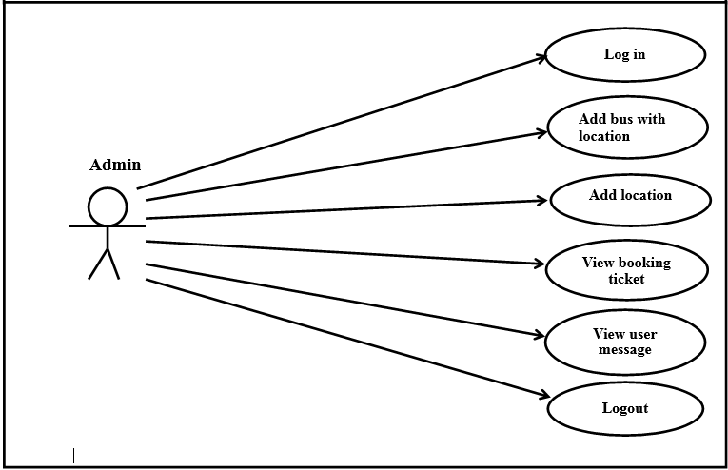

**Fig 4.1: Use case diagram of admin**

**4.4.2 Use-case diagram of user**

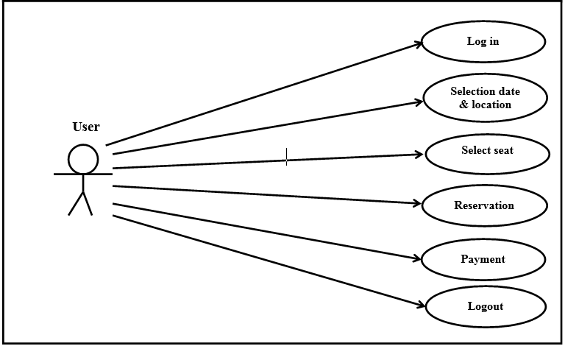

**Fig 4.2: Use case for user**

**4.5 Data flow diagram for proposed system**

Data flow diagram is used to show the flow of data from external entities into the system. It is used to represent the physical and logical area of an information system. The data flow diagrams are pictorial or graphical representation of the Online Bus Ticket Reservation System [8]. The data flow diagram covers all the processes and data storage area, which takes place during any transaction in the system.

**4.5.1 0-level DFD**

Data flow diagram for online bus ticket reservation system is shown in bellow

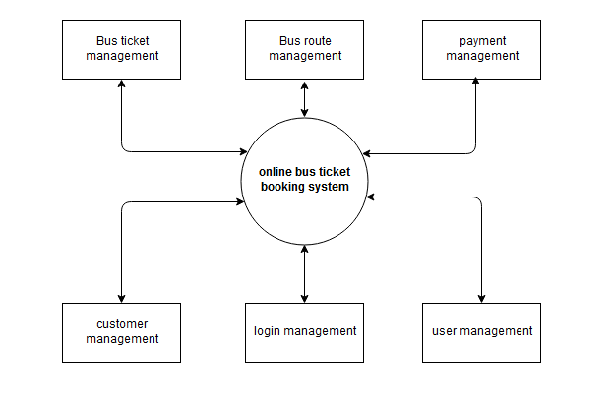

**Fig 4.3 0-level DFD**

**4.5.2 1-level DFD**

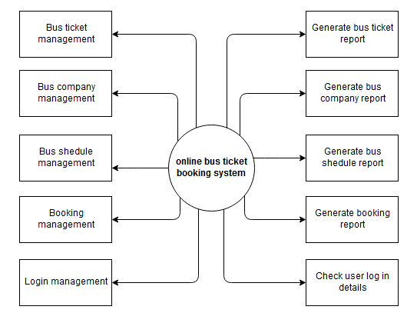

**Fig 4.4 1-level DFD**

**4.5.3 2-level DFD**

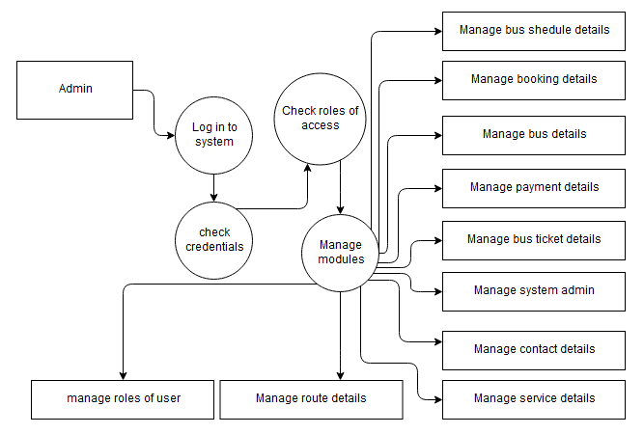

**Fig 4.5: Fig 4.3 2-level DFD**

**4.6 Flow chart for online ticket booking system**

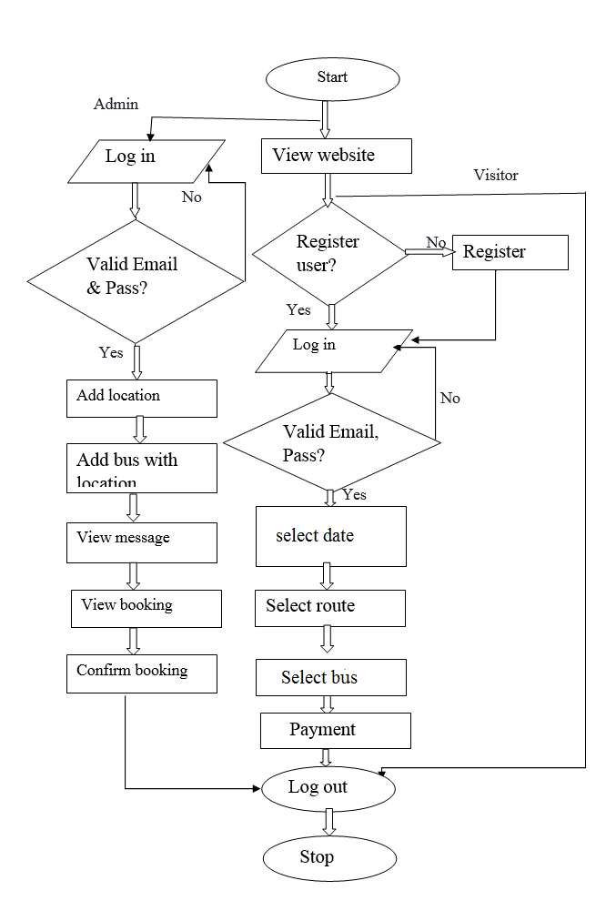

**Fig 4.5 Flow chart of online bus ticket booking system**

**4.8 ER diagram of the proposed system**

An Entity Relationship Diagram (ERD) is a data model describing how entities relate to one another.

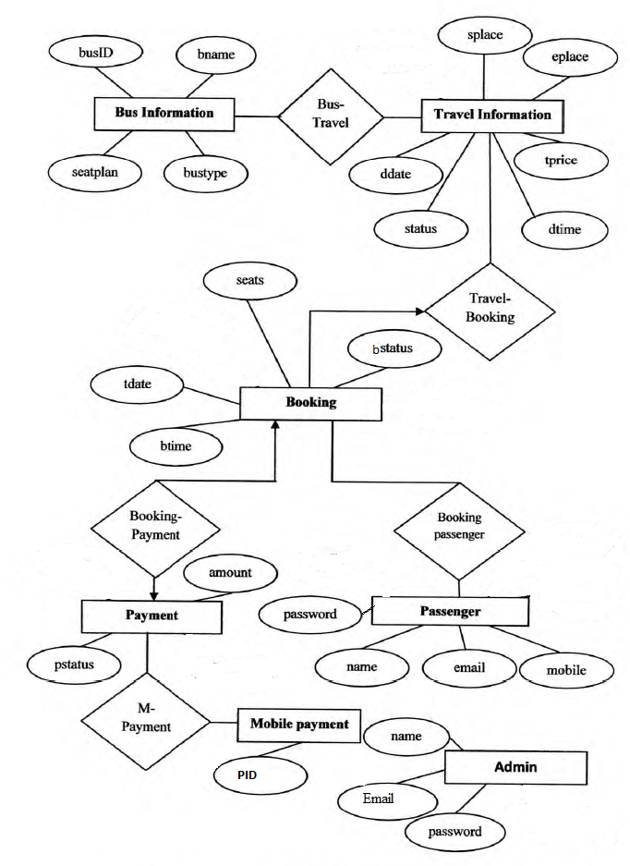

**Fig 4.5: ER diagram of online bus ticket reservation system**

**Chapter 5**

**System implementation & testing**

**5.1 Introduction**

Systems implementation is the process of defining how the information system should be built, ensuring that the information system is operational and used, ensuring that the information system meets quality standard [4].

**5.2 System implementation**

System implementation is the next important phase to develop a system because a system which is well designed but not perfectly implemented is not useable. Here some brief discussion about the proposed system implementation with screenshot

* **User sign in and log in:** First of all, to use the developed system a user need to register. And then log in to the system to get service.

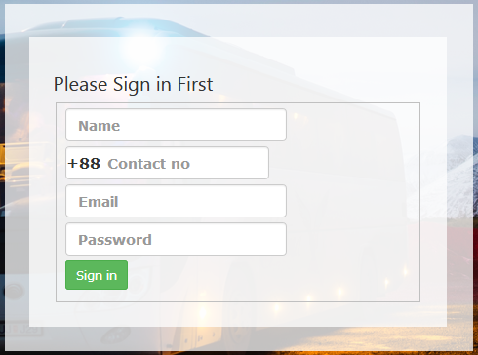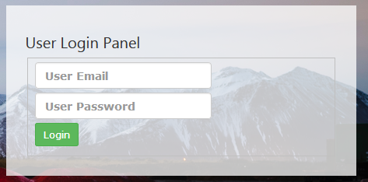

* **Booking ticket:** Enter date of journey with location

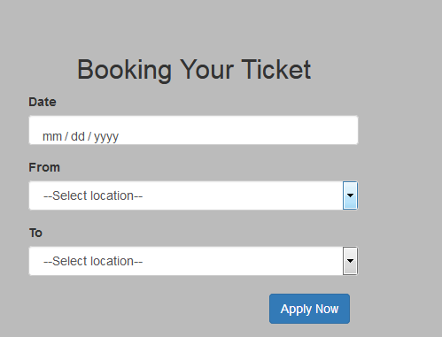

* **Selection and payment:**Selecting seat and pay though any of the payment system added to this system

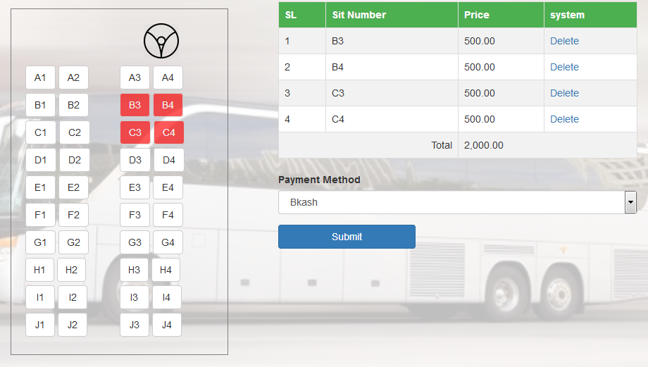

* **Online ticket view:** User can view their ticket in their personal profile after booking the ticket. The admin log in form, admin is the super user of the system.

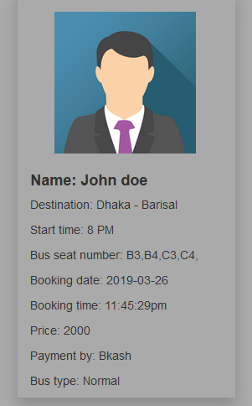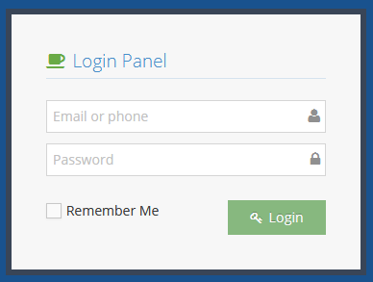

* **Admin can add bus, add district and connection creator of various bus.**

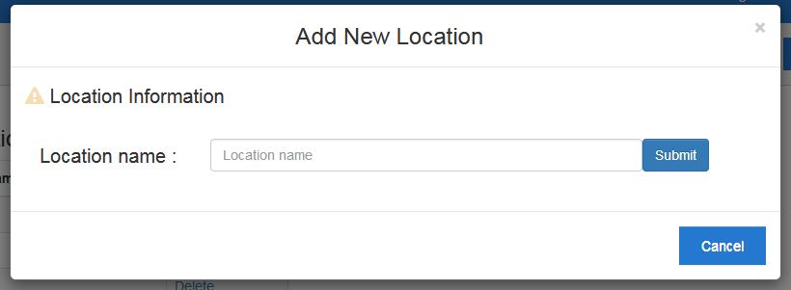

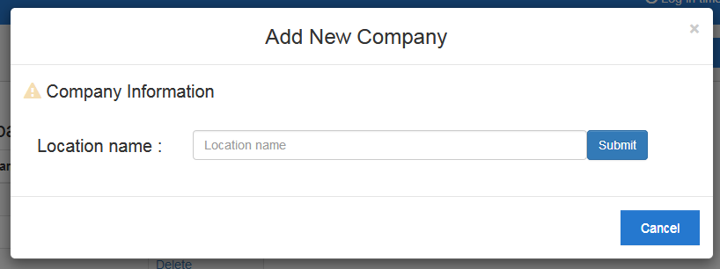

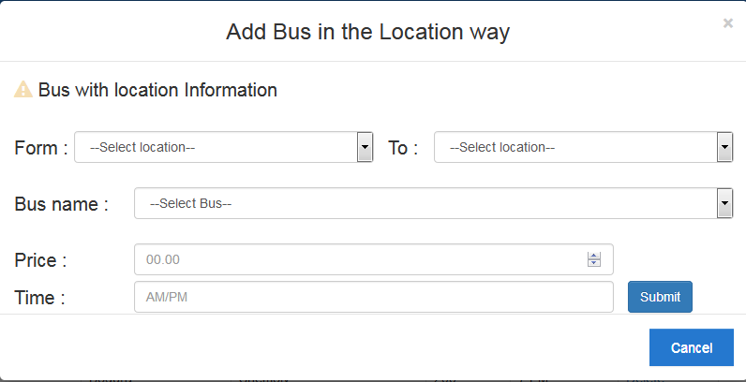

* **Service, contact page**

Service page show the bus connection where there is a route and contact page through which a user can send a sms to the admin which can only be shown by admin.

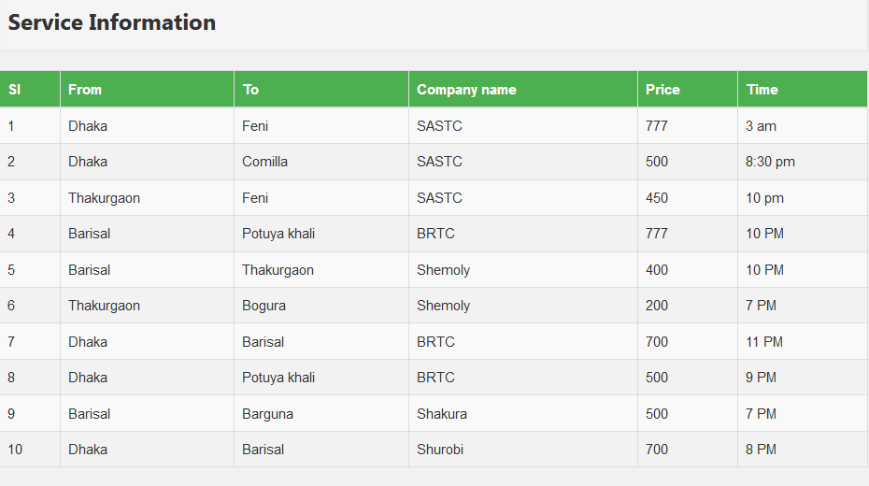

A user can send message to admin through this page

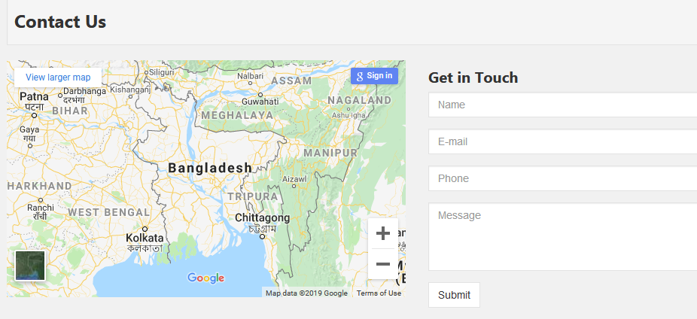

**5.3 System validation (Testing)**

Computer system validation (sometimes called computer validation or CSV) is the process of documenting that a computer system meets a set of defined system requirements [9]. Validation of computer systems to ensure accuracy, reliability, consistent intended performance, and the ability to discern invalid or altered records is a critical requirement of electronic record compliance. The following types of test were performed on the system:

* **Unit Testing:** Testing that each component works very well separately; each module has been tested separately and passed the test.
* **Acceptance (Validation) Testing**: make sure that system really does the imposed requirements. Provides final assurance that software meets all functional, behavioral, and performance requirements.
* **Stress testing:** put greater emphasis on robustness, availability, and error handling under a heavy load, rather than on what would be considered correct behavior under normal circumstances.to determine the stability of the system.
* **Recovery testin**g: The failure which is forced into an application to check how well the recover process is performed

**5.4 Test Case of online bus ticket reservation system**

* Verify that there is portal to add new bus in the system.
* Verify that on filling bus name, from and to destinations, timings and type of bus, new bus get successfully added in the system.
* Verify that user can search for bus by selecting from location –to location for checking their status and timings.
* Verify that search results have bus details, timings and availability.
* Verify that user should see real-time flight status of availability of seats.
* Verify that pricing of different types of bus seats is displayed to the users.
* Verify that user can successfully select single or more than one seat.
* Verify that user cannot select or is not permitted to select seats that are already booked or not allowed for booking [10].
* Verify that on successful booking the ticket should be visible.
* Verify that after successful booking, the seat's status is updated to book.
* Verify the maximum limit of seats that a user can book, selecting more seats than permitted results in error message.

**5.4.1 Admin Case**

The table below show all test cases for admin and how the system responds:

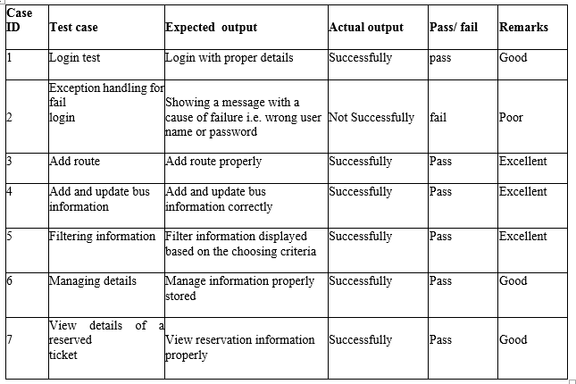

**Table 1: test case for admin case**

**5.4.2 Customer Case:**

Thistable show all test cases for user and how the system responds

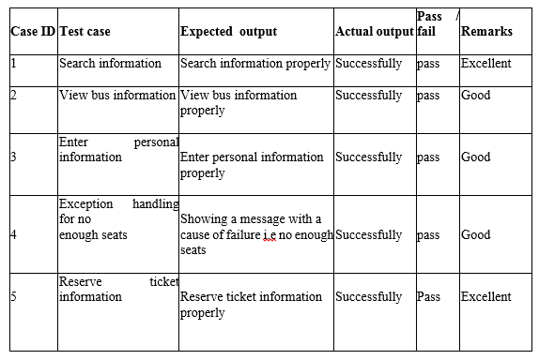

**Table 2: Test case of user case**

**Chapter 6**

**Conclusion & Future plan**

**6.1 Conclusion**

This project designed to meet requirements of a bus reservation system. It has been developed in XHTML, PHP, CSS, JAVASCRIPT and database has been built in MySQL for designing which is fully meet the system’s goals. By using this application, the company can provide reservation services and information to their customers without the limitation of office hours or manpower [7]. It can be observed that computer applications are very important in every field of human endeavor. Here all the information about customer that made reservation can be gotten just by clicking a button with this new system, some of the difficulties encountered with the manual system are overcome. It will also reducing the workload of the staff, reduce the time used for making reservation at the bus terminal and also increase efficiency. The application also has the ability to update records in various files automatically thereby relieving the company’s staff the stress of working from file security of data. This project, as a whole, will give a new way in bus reservations and ticketing processes. The automation and management of seats and reservations will be done online. However, this project does not limit the walk-in passengers that is passengers who visit the company’s counter because it also caters for them.

This also lessens the use of papers like in the traditional way of ticketing.

**6.2 Major limitation of the system**

* The system is developed without linked to Electric Banking system (EBS).
* No notification can be sent during the starting time of bus.
* No facility to print out ticket information as hardcopy.

**6.3 Future scope**

This application can be easily implemented under various situations. Add new features when require. Reusability is possible when require in this application. There is flexibility in all the modules.

This system has a very vast scope in future. The system can be updated in near future when requirement for the same arises, as it is very flexible in terms of expansion. With the proposed software of database Space Manager ready and fully functional the client is now able to manage and hence run the entire work in a much better, accurate and error free manner. The application can be enhanced by many extra features. Some of these features can be summarized as follow:

* Improving the user interface, because the user interface always can be improved
* Established the system which is able to make payment through electric banking system (EBS) to achieve the payment process.
* Develop mobile application, since it is more easy to use Develop a version for fees collection in public transport
* Provide SMS based alerts and email notifications for bookings.
* The wallet can be developed to handle discounts on the point’s basis. It can also be used to provide referral code concept for referring friends.
* Chat feature can be included in the application to chat with customer care.
* Feature that will allow the customer to save favorite routes and provide discounts for same.
* Introduce coupon management for providing coupons which customers can use to avail discounts.
* Check whether the seats are arranged in proper manner like the neighbors of the ladies should be ladies.
* Design the system to provide worldwide travel facilities
* Provide Payment protection.
* Design the system to online fraud prevention

**References**

1. Lu, W. (2007).An Analysis of Airline E-commerce Strategies in Ticket Distribution.

2. Ceipidor, U. B., Medaglia, C. M., Marino, Morena, Sposato, S. Moroni, Morgia, M. La. (2013). Mobile ticketing with NFC management for transport companies.Problems and solutions. 2013 5th International Workshop on Near Field Communication.

3. Alaya, S. M. (2014). Development of an Online Bus Ticket Reservation System for a Transportation Service in Nigeria,

4. Al-hijaj, A. A. Jabbar(2013). Design and developing online Iraqi bus reservation system by using unified modeling language.

5. A. Y. A. M. S. Uddin, "E-Wallet System for Bangladesh an Electronic Payment System". (12 February 2014)

6. “Online Ticket Booking System” by Reaz Ahmed (14 November 2011).

7. “Travel reservation system” by Mahajan madhurivikas(2004-2005)I.m.rCollege,Jalgaon,an institution recognized by UGC.

8. “Residentialonline booking system” by David Otieno and Samantha Akinyi(November 2013),Uganda Christian University.

9. Baleleng, T. (2011). Hotel Reservation Techniques. Accessed on 2-11-2013. <http://artificialintelligenceseo.info/2011/09/hotel-reservation-techniques>.

10. Tatiana, D. (2011). The Impact of Online Booking Systems on Customer Loyalty. Romania, United Kingdom.

11. “Development of web application for bus information management system” byMd. Khaled Hossain Ansary, Institute ofInformation and Communication Technology (2008)